Request for Proposal

Integrated Business Planning
Table of Content:

1. Request for Proposal 2
1.1. Overall description 2
1.2. Statement of Purpose 2
1.3. Background Information 2
1.4. Scope of Work 3
1.5. Outcome and Performance Standards 4
1.6. Deliverables 4
1.7. Requirements for Proposal Preparation 4
1.8. Evaluation and Award Process 4
1.9. Overall Schedule 4
1.10. Point of contact for future correspondence 4
1.11. Requirement list 5
1.12. Annexure-1 global supply chain 10
1.13. Annexure -2 To be process flow 11

Request for Proposal

Overall description

“Company” is engaged in the development, manufacture, sale, and servicing of consumables and systems for genetic analysis in the life sciences and clinical healthcare markets. Oracle’s JDEdwards Enterprise One ERP software (Release 8.12) has been rolled-out to all manufacturing and distribution units. Overall product flow and organizational units are described in the annexure 1.
We are planning to augment our ERP footprint with additional capabilities in the S&OP (sales and operations planning), forecasting and integrated business planning tools like network planning, inventory optimization, etc. A high-level business process flow of the requirement is described in the annexure 2.
We would like the vendor’s response for this RFP along with the custom-demo highlighting how your solution meets our needs. Solid and proven integrations with ERP are key differentiator for this project.

Statement of Purpose

Augment Oracle’s JD Edwards’ ERP solution with advanced supply-chain solutions like sales & operations planning; demand planning, inventory optimization and production scheduling.

Background Information

“Company” is a pioneer in creating breakthrough tools that are driving the genomic revolution. By applying the principles of semiconductor technology to the life sciences, “Company” develops and commercializes systems that enable scientists to improve quality of life. The Company's customers include pharmaceutical, biotechnology, agrichemical, diagnostics, and consumer products companies, as well as, academic, government, and other non-profit research institutes. “Company” offers an expanding portfolio of integrated products and services, including its integrated GeneChip® platform, to address growing markets focused on understanding the relationship between genes and human health. “Company” has about 1,100 employees worldwide.

Our major products could be grouped as arrays, reagents and instruments. Arrays come from Singapore manufacturing plant and reagents are manufactured at Cleveland/Ohio facility. Instruments are sourced directly from vendors and sent to distribution centers. Finished Goods are distributed to customers through a network of distribution centers in Kentucky, Nijmegen/Netherlands and Singapore. There are 5000+ finish goods for these products. Products have bills and routing setup at their respective manufacturing plants. Products are configured as sales kits, where distribution center can assemble the component and send the kit item to the customers.
Company: “Company”
Brands: Genechip, USB, Panomics
Product groups: arrays, reagents, instruments
Product sub-groups: multiple levels exist.
SKUs: 5000+ finished goods (about 1000 of them forecast driven)
Thousands of components defined through bills, kits and phantom assemblies.

Unique differentiators:
Product expiration date, sell-by date (customer need their shelf life before they could use the product) critical
Products and components are lot controlled, extensively. Many of genechip products have shelf life of a year or less.
Some products are under FDA regulation
Company is ISO certified (13485)
Combination of long-lead time (instruments) to very short lead-time (consumables) products
Many saleable products exist as kits. (Distribution centers assemble the components and ships to the customer)
Currently gross regeneration of DRP/MRP in ERP on a daily basis.
Combination of product safety levels with product lead-time is critical to meet customer satisfaction at the distribution centers

Scope of Work

Deliver the software solution including the implementation, consulting, pre & post-golive support. The data integration between ERP and SCP is a key factor for sustaining the project. The SCP modules could be implemented in phases for ease of user training and progressive adoption of this new technology in the company

Outcome and Performance Standards

Software delivery, implementation timelines and support

Deliverables

- RFP response
- Solution demonstration with key reports
- Software contract agreement
- Implementation timeline requirements, TCO, internal & external resource requirements

Requirements for Proposal Preparation
Initial proposal with your company’s background, industry and customer profiles, solution offered.
Vendors will present a custom-built demo to show the “Company” team how the solution meets our needs. Additional demo data could be sent to the presenter, if required. Customer- reference calls & site visit

Evaluation and Award Process
“Company” core team will review the solution offered along with implementation and integration requirements.

Overall Schedule
Jan- Feb 2011. RFP sent to vendors
Late Feb. Initial product demonstrations
March 2011. Detailed discussions with the vendors

Point of contact for future correspondence
Mathur Ravikumar
3420 Central Expressway, Santa Clara CA 95051
Phone: 408-731-5915
mathur_ravikumar@”Company”.com

Requirement list

Area | Requirement detail | check-  point
Forecasting  (replacing JDE  functionality) | - Ability to simulate future forecast based on various statistical models. The sales history has to be uploaded from JDE ERP system  - Ability to capture different manual forecast inputs from sales, marketing, finance depts. Units & Dollar level forecast. Forecast interpreted in different units of measure.  - Ability to track manual overrides  - Ability to integrate with Salesforce.com  - Ability to capture internal demand separately and monitor the usage.  - Ability to determine and apply the best-fit model and track the forecast accuracy. Historical trend analysis. Graphical dashboard capability to analyze and compare different models.  - Ability to measure bias  - Run what-if analysis without impacting the current production flow.  - Forecast data at SKU, product family and/or product line levels. Users across different functions able to see their data points.  - Ability to forecast for different hierarchy and on different levels of hierarchy  - Validate the forecast data points and fine-tune to different forecast buckets if necessary. Example: EOL products not having consistent demand in the past. (phase in/phase out process)  - Extend the final forecast access to vendors thru EDI or portal, based on data filters or conditions  - Workflow that communicates the final forecast into the transaction system and routing management approvals.  Ability to gather customer forecast and integrate into global forecast Transfer the final approved forecast data into ERP system.  - New product forecasting (like item, attribute based forecasting)  - Kit forecasting on dependent and independent levels  - Ability to support an S&OP process  - Ability to calculate forecast consumption
network planning  and DRP  (replacing JDE  DRP functionality) | - Ability to calculate inventory requirements based on demand and safety stock calculations  - Suggest safety stock at distribution centers based on the past usage and demand pattern. Safety stock vs future forecast in the distribution centers. Visual based.  - System suggesting make or buy messages from the forecast/safety stock/customer demand in the global distribution center. The message should route to the relevant manufacturing location.  - System suggesting moving inventory from one DC to another to satisfy customer demand. Constraints on cost and transit lead-time to be evaluated by the tool.  - Distribution planning to consider alternative sourcing, transit leads time and consolidates messages to avoid LTL shipments.  - Include company holiday calendar and weekends – manufacturing and regional. Local time zones.  - Ability to create and determine ATP.  - Ability to prioritize demand and allocate inventory  - Ability to plan on different levels of the hierarchy and for different time horizons (aggregate planning)  - Ability to visualize network supply to demand imbalances
inventory  optimization &  MRP  (replacing JDE MRP functionality) | - Predict the future inventory costs based on the current schedule of supply and demand.  - Ability to consider different supply and demand variability  - Ability to define inventory turns at product level. System to alert the users when the defined parameters exceed in the data model.  - Evaluate the impact of expired materials (both finished goods and components) and sell-down/re-assay materials  - Real-time planning messages to order or make products.  - Replenish perishable or sell-down products based on their declining shelf life.  - Identify and alert the impact of future E&O. Exclude the future expired inventory in the planning process  - Identify and alert the EOL products – de facto  - multi echelon inventory optimization vs. MRP/DRP functionality  - Generate planning messages for procurement or manufacturing, based on the bills, routing.  - Ability to push those messages to ERP system for day-to-day execution  - On-demand data refresh into the model and export back to ERP system  - No limitation on bills. Example: GCS instrument bills in 1000.  - Ability to account for manufacturing and operational constraints  - Ability to include total landed costs  - Ability to optimize inventory strategies and flow paths  - Time supply  - Demand over lead-time  - Regional Safety Stock  - Global Safety Stock  - Sum up from low level detail within the hierarchy  - Force down an inventory budget and disseminate down within the hierarchy
Capacity planning  (replacing JDE  functionality) | - Rough cut capacity planning to analyze resource constraints  - Graphical tool that helps management to identify potential problem areas with respect to resource usage and limitations  - Ability to simulate and run what-if analysis for capacity requirements. Major order, machine downtime, resource splits, etc.  - Ability to compare scenarios side by side  - Ability to document and track assumptions associated with each scenario
Data | - Real-time integration between ERP and SCP modules.  - Import/Export Capabilities  - Data Dump for users  - Reports – replace current Excel reports  - User defined reports  - Ad hoc as well as scheduled reporting
Master production  Scheduling  (new functionality  – desired list) | - Schedule work orders based on DRP/MRP  - Identify resource constraints and offer solutions  - Absorb user-driven manual interventions and re-plan the master schedule  - Visual display of all planned, firmed-up and in-progress work orders within a time frame  - Reports like dispatch list to be sent to shop floor managers.  - Ability in input supporting resource constraints like inspection, document control and other functional groups.
S&OP  (new functionality  - Desired list) | - Facilitate collaboration among different functional groups to visualize overall inventory, supply & demand patterns and potential bottlenecks. A single integrated tool and dashboard capabilities to display critical information.  - Top-down and bottom-up data flow. Ability to see capacity constraints when the top level S&OP plan is changed.  - Slice & dice the data into various product groups and manufacturing/distribution facilities  - Inquire or report future material shortage against the approved supply plan

Annexure-1 global supply chain
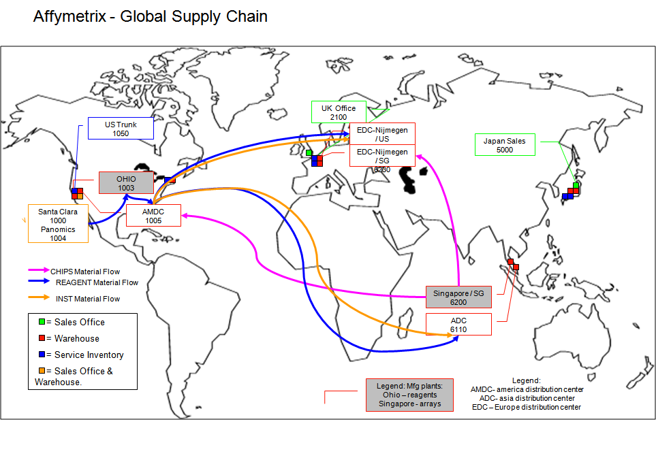

Annexure -2 To be process flow

